CREATE TABLE BRANCH(BRANCH_NAME VARCHAR2(10), BRANCH_CITY VARCHAR(10), ASSESTS REAL,PRIMARY KEY (BRANCH_NAME));

CREATE TABLE ACCOUNTS(ACC_NO NUMBER(5),BRANCH_NAME VARCHAR(10),BALANCE REAL,PRIMARY KEY(ACC_NO), FOREIGN KEY(BRANCH_NAME) REFERENCES BRANCH(BRANCH_NAME));

CREATE TABLE DEPOSITOR(CUSTOMER_NAME VARCHAR2(10),ACC_NO NUMBER(5),PRIMARY KEY (CUSTOMER_NAME,ACC_NO),FOREIGN KEY (CUSTOMER_NAME) REFERENCES CUSTOMER(CUSTOMER_NAME),FOREIGN KEY (ACC_NO) REFERENCES ACCOUNTS(ACC_NO));

CREATE TABLE CUSTOMER(CUSTOMER_NAME VARCHAR2(10), CUSTOMER_STREET VARCHAR(10),CUSTOMER_CITY VARCHAR2(10),PRIMARY KEY(CUSTOMER_NAME));

CREATE TABLE LOAN(LOAN_NO NUMBER(5),BRANCH_NAME VARCHAR2(10), AMOUNT REAL,PRIMARY KEY(LOAN_NO),FOREIGN KEY (BRANCH_NAME) REFERENCES BRANCH(BRANCH_NAME));

CREATE TABLE BORROWER(CUSTOMER_NAME VARCHAR2(10),LOAN_NO NUMBER(5),FOREIGN KEY(CUSTOMER_NAME) REFERENCES CUSTOMER, FOREIGN KEY(LOAN_NO) REFERENCES LOAN(LOAN_NO));

INSERT INTO BRANCH VALUES('&BRANCH_NAME','&BRANCH_CITY',&ASSESTS);

SELECT * FROM BRANCH;

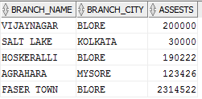

INSERT INTO ACCOUNTS VALUES('&ACC_NO','&BRANCH_NAME',&BALANCE);

SELECT * FROM ACCOUNTS;

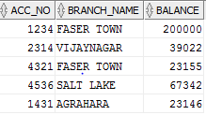

INSERT INTO CUSTOMER VALUES('&CUSTOMER_NAME','&CUSTOMER_STREET','&CUSTOMER_CITY');

SELECT * FROM CUSTOMER;

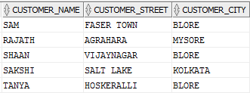

INSERT INTO DEPOSITOR VALUES('&CUSTOMER_NAME','&ACC_NO');

SELECT * FROM DEPOSITOR;

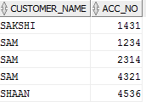

INSERT INTO LOAN VALUES(&LOAN_NO,'&BRANCH_NAME',&AMOUNT);

SELECT * FROM LOAN;

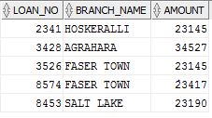

INSERT INTO BORROWER VALUES('&CUSTOMER_NAME',&LOAN_NO);

SELECT * FROM BORROWER;

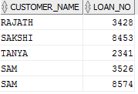

SELECT D.CUSTOMER_NAME,B.BRANCH_NAME,A.ACC_NO FROM DEPOSITOR D,BRANCH B,ACCOUNTS A WHERE A.ACC_NO=D.ACC_NO AND B.BRANCH_NAME=A.BRANCH_NAME AND B.BRANCH_NAME="FASER TOWN" AND ( SELECT A.ACC_NO FROM ACCOUNTS A HAVING COUNT(*)>=2);



SELECT D.CUSTOMER_NAME FROM DEPOSITOR D WHERE D.ACC_NO=ALL(SELECT A.ACC_NO FROM BRANCH B,ACCOUNTS A WHERE B.BRANCH_CITY="MYSORE" AND A.BRANCH_NAME=B.BRANCH_NAME);



DELETE FROM ACCOUNTS WHERE BRANCH_NAME IN(SELECT BRANCH_NAME FROM BRANCH WHERE BRANCH_CITY="BLORE");

SELECT * FROM ACCOUNTS;

